For immediate release Tuesday 8th January 2019
Little Saplings toddler group is a mud success
Pendle Hill Landscape Partnership’s Little Saplings toddler group has been deemed a huge success since its launch in September 2018.
The toddler group, which is funded by the Heritage Lottery Fund and in partnership with the Ernest Cook Trust, has seen 421 under five year olds attend the bi-monthly Wednesday events at local nature sites within Pendle and the Ribble Valley.
The Little Saplings toddler group is one of several initiatives set up by the Partnership, aiming to connect local people, including children, to their local area. A 2016 Unilever survey revealed 75% of children spend less time enjoying the outdoors than prison inmates.
Outdoor Learning Officer Alison Cross, said: “I hope the Little Saplings sessions will spark an early interest in wildlife for the children. Hopefully, it will encourage families to explore their local area and learn about nature and how to respect it. With many projects at Pendle Hill starting in the next three years, Little Saplings is the start of our outdoor learning programme where we hope more families will get involved.”
The one-and-a-half-hour sessions take place at Spring Wood picnic site, Whalley and Victoria Park, Nelson, and allow toddlers to play independently in woodland, developing life skills using the Forest School ethos.
Grandparents, who bring their three year old granddaughter to Nelson’s Victoria Park, said: “It’s a great activity to come and get fresh air, get dirty and she loves the freedom of playing in the mud, leaves and nature. Mud kitchen is her favourite.”
Through the support of the Ernest Cook Trust it allows Pendle Hill Landscape Partnerships to deliver themed nature play sessions, including mud kitchen, den building, Stick Man trail and minibeast hunting.
Romy Duckett, who attends Spring Wood with her two year old daughter, said: “It is great to get out and about in nature, rather than being inside. My daughter really enjoys these sessions and I will definitely be booking for the 2019 sessions.”
Families can now book their 18 months to five year olds onto the 2019 sessions via the Pendle Hill Landscape Partnership website (https://pendlehillproject.com/little-saplings). The next session is Wednesday 23rd January with further details about times and locations available on the website.
These toddler events wouldn't be possible without funding from the Heritage Lottery and the Ernest Cook Trust, plus the family learning volunteers who help Alison. "I would like to thank my lovely volunteers who help me deliver high quality and fun packed Little Sapling events, I couldn't clean up all that mud without you" If you would like to help with the preparation and delivery of Pendle Hill Landscape Partnership family events, then get in touch with the team at https://pendlehillproject.com/get-involved or email: volunteer@pendle-hill-lp.co.uk or call 01200 420420.
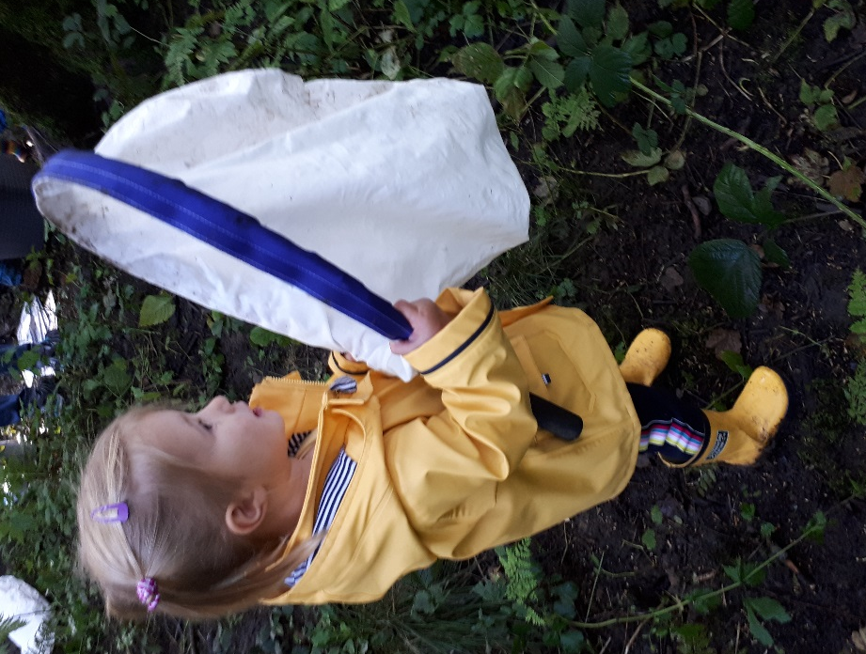
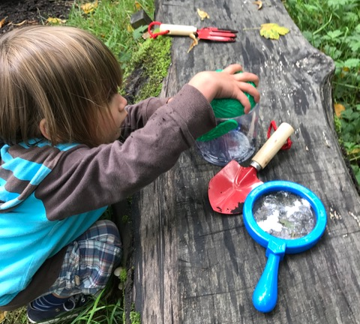
Children enjoy minibeat hunting with a sweep nets, bug pots and magnifying glasses funded by the Ernest Cook Trust

Children had fun making a hedgehog out of clay and learning about hibernation in October

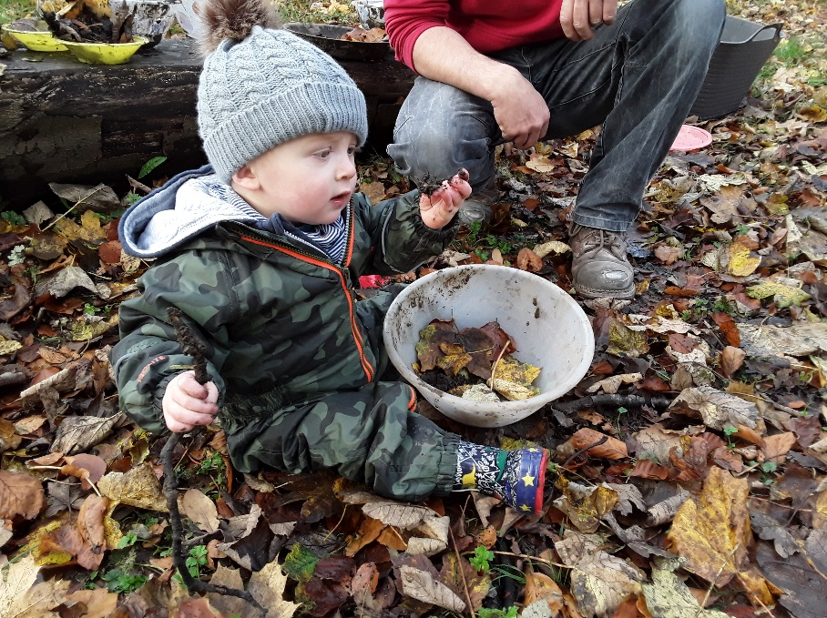

18month old enjoys mud kitchen in Victoria Park woodland

EDITORS NOTES
- The Pendle Hill landscape partnership is led by the Forest of Bowland AONB.
- The partnership aims to:
I. restore, enhance and conserve the heritage and landscape of Pendle Hill
II. reconnect people with their past and their landscape
III. bring the two sides of the hill together
IV. create a sustainable future for the environment, heritage and for visitors' experience of Pendle Hill
- The scheme was awarded a National Lottery grant of £1.8million by the Heritage Lottery Fund in January 2018. These funds will be delivered from 2018-2022 and will be matched with a further £1m raised locally.
- The scheme is made up of a dozen projects which safeguard the area's wildlife and heritage and improve people's access to this popular countryside area. We will do this by providing opportunities for training and volunteering; by supporting research and devising creative and digital interpretation to inspire a new generation about our heritage; by restoring important landscape features, and by working with communities to re-tell the stories of radical Pendle people. The scheme will increase pride in this special place and raise aspirations amongst communities, and it will bring in new investment to support the environment and the economy.
- The Pendle Hill landscape partnership is supported by National Lottery players through the Heritage Lottery Fund and by the Forest of Bowland AONB. Partners include representatives of parish councils, the landowning and farming community, Pendle and Ribble Valley Borough Councils, Lancashire County Council, statutory bodies, tourism businesses and volunteers.
- Projects will be delivered by the AONB team, plus local delivery partners including In –Situ Arts, the Dry Stone Walling Association, Mid Pennine Arts and Ribble Rivers Trust.
- The Pendle Hill LP covers 120 square kilometres, stretching from Gisburn down to Whalley, and from Clitheroe across to Nelson and Padiham.
- The Hill is well known as a beauty spot and is heavily visited by residents of the local towns: it is a perfect place for walking and cycling. The area's heritage is dominated by the story of the Pendle Witches, but there are lots more stories to tell including the founding of the Quaker movement, non- conformists and radicals, Roman and Bronze Age settlers, medieval farming systems and early industrial developments. The network of dry stone walls and hedgerows give the area a distinctive feel, and the landscape is also important for its wild moorland, rare birds and woodlands.
- For further information contact the LP Scheme Manager cathy.hopley@lancashire.gov.uk on 07891 537835 / 01200 420420
- Visit the project website at www.pendlehillproject.com or visit our Facebook page 'Pendle Hill Project' for up to date news and views.
About the Heritage Lottery Fund
Thanks to National Lottery players, we invest money to help people across the UK explore, enjoy and protect the heritage they care about - from the archaeology under our feet to the historic parks and buildings we love, from precious memories and collections to rare wildlife. www.hlf.org.uk Follow us on Twitter, Facebook and Instagram and use #HLFsupported

About The Ernest Cook Trust
The Outdoor Learning project is led by the Outdoor Learning Officer, who is employed through the Ernest Cook Trust. ECT was founded as an educational trust by Ernest Cook, grandson of Thomas Cook (the travel agent), in 1952. ECT's vision is inspiring young people to achieve better education and life outcomes by learning from the land. In order to increase this reach they have begun to partner with a range of organisations in different parts of the UK, hence their involvement with the Pendle Hill Landscape Partnership. The Outdoor Learning Officer will provide a key role in broadening learning aspects of the PHLP, providing additional family activities and formal education methods to engage with the PHLP community

