PRESS RELEASE

For immediate release Friday 21st June 2019
Free Family Fun within the Pendle Hill Landscape
Pendle Hill Landscape Partnership are inviting local families to join in with free family nature events during the summer. These sessions hope to spark an interest in wildlife for the children. While encouraging families to explore their local area, learn about nature and local history of the Pendle Hill area.
The National Lottery Heritage Funded Landscape Partnership scheme started in April 2018. The projects' Outdoor Learning Officer, who is funded by the Ernest Cook Trust, has been delivering free family events for a year. Due to their success and popularity, there are more family events planned for this summer. They range from den building to natural art sessions to mini Bio-Blitz's sessions.
To celebrate the range of wildlife at the Clarion house, near Roughlee, 3 mini bio-blitz's will be held this summer on 30th June, 1st and 15th August. This is part of the Wild About Pendle Project within the partnership scheme which aims to bring people closer to nature and to ensure a bright future for our wildlife. The bio blitzes bring local nature experts along to assist families to identify wildlife within important habitats. The data collected will help the partnership team to conserve the area and monitor wildlife over time. Sarah Robinson, the partnerships Farming and Wildlife Officer, said "there is a diverse amount of invertebrates and plants that live within the Clarion House grounds. We need to record what we can see over the 4 year project, which helps me to plan the conservation methods needed to conserve it for future generations." These free family events book up quickly. Go to the Pendle Hill Landscape Partnership website (https://pendlehillproject.com/whats-on) to find out more and to book.
The Pendle Hill Project also deliver an outdoor toddler group called Little Saplings, for under 5 year olds. The one-and-a-half-hour sessions take place at Spring Wood picnic site, Whalley and Victoria Park, Nelson, and allow toddlers to play independently in woodland, developing life skills using the Forest School ethos. Parents describe the sessions as "somewhere my child can find bugs, play in mud and learn about nature". These free events will continue to run during the summer holidays, but again, booking is essential.
Outdoor Learning Officer Alison Cross, who delivers these bi-monthly sessions said: “Little Saplings events have enabled families to discover more about their local area, learn about nature and how to respect it. It has been a privilege to watch little ones pick up their first worm, make mud pies and be connected with nature using their imagination. I hope more families will get involved."
Local people are invited to get involved by volunteering and assisting with the delivery of the family events. This opportunity would suit those who want experience of working with children, or delivering family events. This also includes those who have some free time and wish to pass on their nature knowledge to the next generation. Head to the website to find out more about joining the team and the fun activities you can be part of.
If you would like to find out more about Pendle Hill Landscape Partnership family events and working with schools, then get in touch with the team at https://pendlehillproject.com/get-involved or email: volunteer@pendle-hill-lp.co.uk or call 01200 420420.
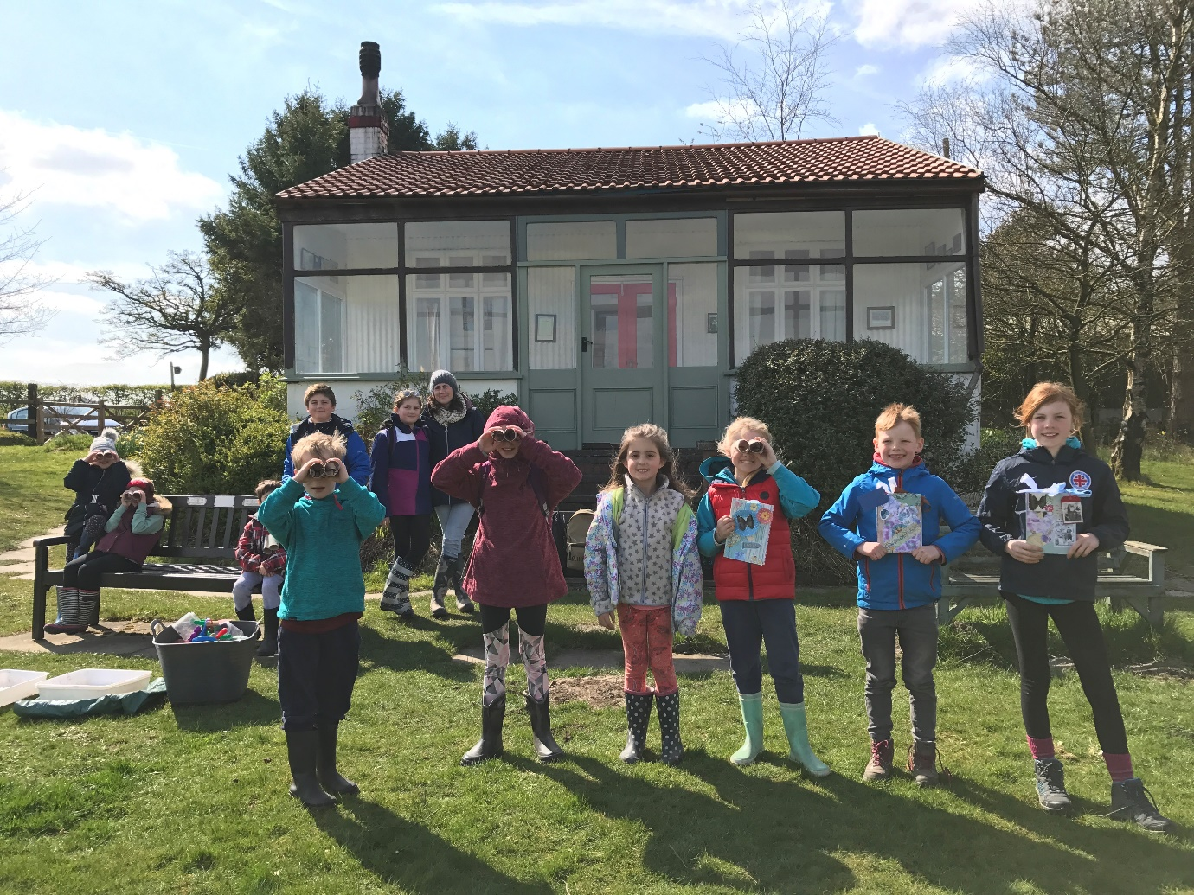
Family fun at the Clarion House
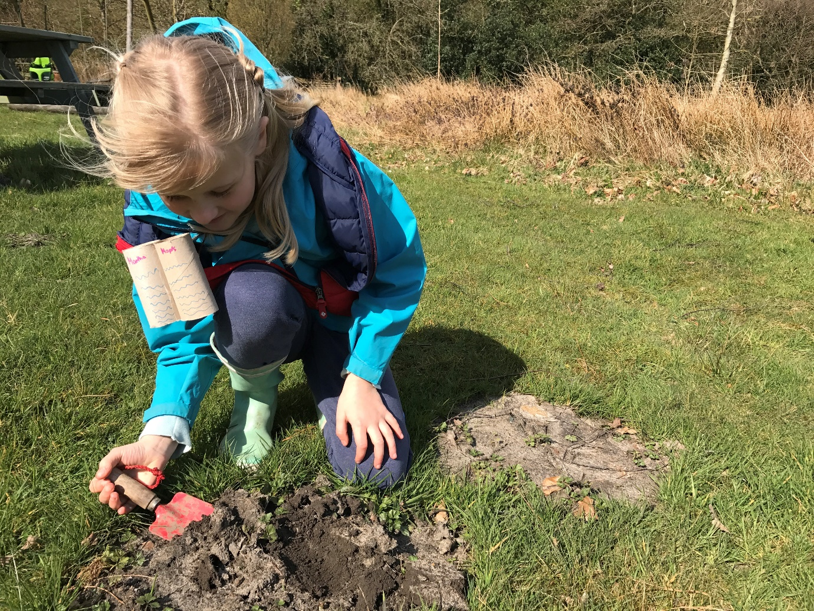
Digging for minibeasts at free family event
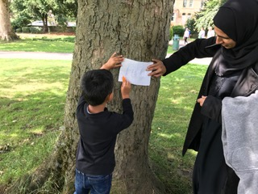

Bark rubbing in Victoria Park
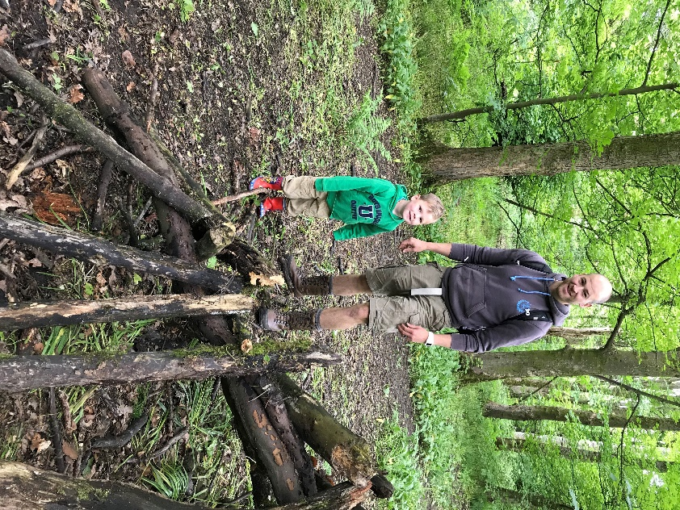
Dad and son den building at Little Saplings

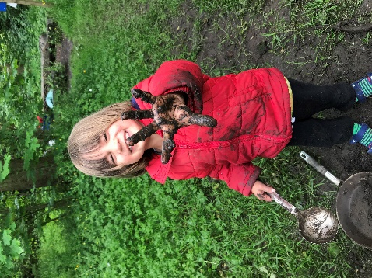
muddy hands in mud kitchen, at Little Saplings
EDITORS NOTES
- The Pendle Hill landscape partnership is led by the Forest of Bowland AONB.
- The partnership aims to:
I. restore, enhance and conserve the heritage and landscape of Pendle Hill
II. reconnect people with their past and their landscape
III. bring the two sides of the hill together
IV. create a sustainable future for the environment, heritage and for visitors' experience of Pendle Hill
- The scheme was awarded a National Lottery grant of £1.8million by the National Lottery Heritage Fund in January 2018. These funds will be delivered from 2018-2022 and will be matched with a further £1m raised locally.
- The scheme is made up of a dozen projects which safeguard the area's wildlife and heritage and improve people's access to this popular countryside area. We will do this by providing opportunities for training and volunteering; by supporting research and devising creative and digital interpretation to inspire a new generation about our heritage; by restoring important landscape features, and by working with communities to re-tell the stories of radical Pendle people. The scheme will increase pride in this special place and raise aspirations amongst communities, and it will bring in new investment to support the environment and the economy.
- The Pendle Hill landscape partnership is supported by National Lottery players through the Heritage Fund and by the Forest of Bowland AONB. Partners include representatives of parish councils, the landowning and farming community, Pendle and Ribble Valley Borough Councils, Lancashire County Council, statutory bodies, tourism businesses and volunteers.
- Projects will be delivered by the AONB team, plus local delivery partners including In –Situ Arts, the Dry Stone Walling Association, Mid Pennine Arts and Ribble Rivers Trust.
- The Pendle Hill LP covers 120 square kilometres, stretching from Gisburn down to Whalley, and from Clitheroe across to Nelson and Padiham.
- The Hill is well known as a beauty spot and is heavily visited by residents of the local towns: it is a perfect place for walking and cycling. The area's heritage is dominated by the story of the Pendle Witches, but there are lots more stories to tell including the founding of the Quaker movement, non- conformists and radicals, Roman and Bronze Age settlers, medieval farming systems and early industrial developments. The network of dry stone walls and hedgerows give the area a distinctive feel, and the landscape is also important for its wild moorland, rare birds and woodlands.
- For further information contact the LP Scheme Manager cathy.hopley@lancashire.gov.uk on 07891 537835 / 01200 420420
- Visit the project website at www.pendlehillproject.com or visit our Facebook page 'Pendle Hill Project' for up to date news and views.
About the Heritage Fund
Thanks to National Lottery players, we invest money to help people across the UK explore, enjoy and protect the heritage they care about - from the archaeology under our feet to the historic parks and buildings we love, from precious memories and collections to rare wildlife. www.hlf.org.uk Follow us on Twitter, Facebook and Instagram and use #HLFsupported

