PRESS RELEASE
For immediate release 1st July 202
Family Summer Adventure Challenge
The summer holidays are looming, and they might be a bit different this year. Lancashire families are being invited to take on a wildlife and heritage challenge, as a focus for the six weeks ahead. The Pendle Hill Landscape Partnership team are delivering a John Muir Discovery Award during the school summer holidays. The free family led challenge will create some wonderful 2020-summer memories and get children and adults hooked on discovering the nature around us and the history underneath our feet.
Jayne Ashe, the Pendle Hill's Community Engagement officer says, "Unfortunately, we cannot deliver the John Muir group activities that we had planned during 2020, but we would like to support local families on their adventure to complete this challenge from home and in their local wild places!"
The Pendle Hill team have revamped their John Muir Family Award to suit the current situation. Families are encouraged to sign up online for this free adventure challenge, where they will receive activity inspiration, guidance and a certificate on completion. The John Muir Discovery Award involves families spending 25 hours over 5 weeks discovering, exploring and conserving local outdoor spaces.
Alison Cross, the Outdoor Learning officer for the project, employed by the Ernest Cook Trust, is looking forward to assisting local families reconnecting with nature. "We are offering guidance, resources and virtual support to all involved. Each week families will receive a newsletter containing the latest tasks, activities, challenges and methods of sharing what they have discovered. We have five themed challenges to complete, these range from minibeast hunting, to archaeology and local history, learning about Pendle at night and the wildlife that lives there."
Jayne adds, "The weekly challenges are all family led and can be easily adapted to suit each family. You do not need to have a garden or yard. The activities are for all families with children of all ages and abilities. Adults are encouraged to be part of the adventure too."
The project is supported by National Lottery Heritage Fund and the Ernest Cook Trust, as part of the four year Landscape Partnership, led by the Forest of Bowland AONB. This summer challenge is one of many community projects that are being delivered by the team. During the four years, the team hopes to inspire a new generation about heritage, while engaging with more people from a wider range of communities. Working with the John Muir Trust has allowed a national scheme to be implemented locally to suit the Pendle Hill landscape and the community.

Alison hopes that the families who receive the John Muir award will learn more about our local wild places, nature and heritage. "There are many benefits to being in the outdoors, and we want everyone to experience these! When all children return to school, they will have an exciting experience to tell their friends and teachers about."
To find out more and to register, head to https://pendlehillproject.com/2020-outdoor-adventure Please register for this exciting opportunity before 17th July 2020.
If you have questions contact us via pendlehill@ernestcooktrust.org.uk or call 07770273643 or 07967591176.
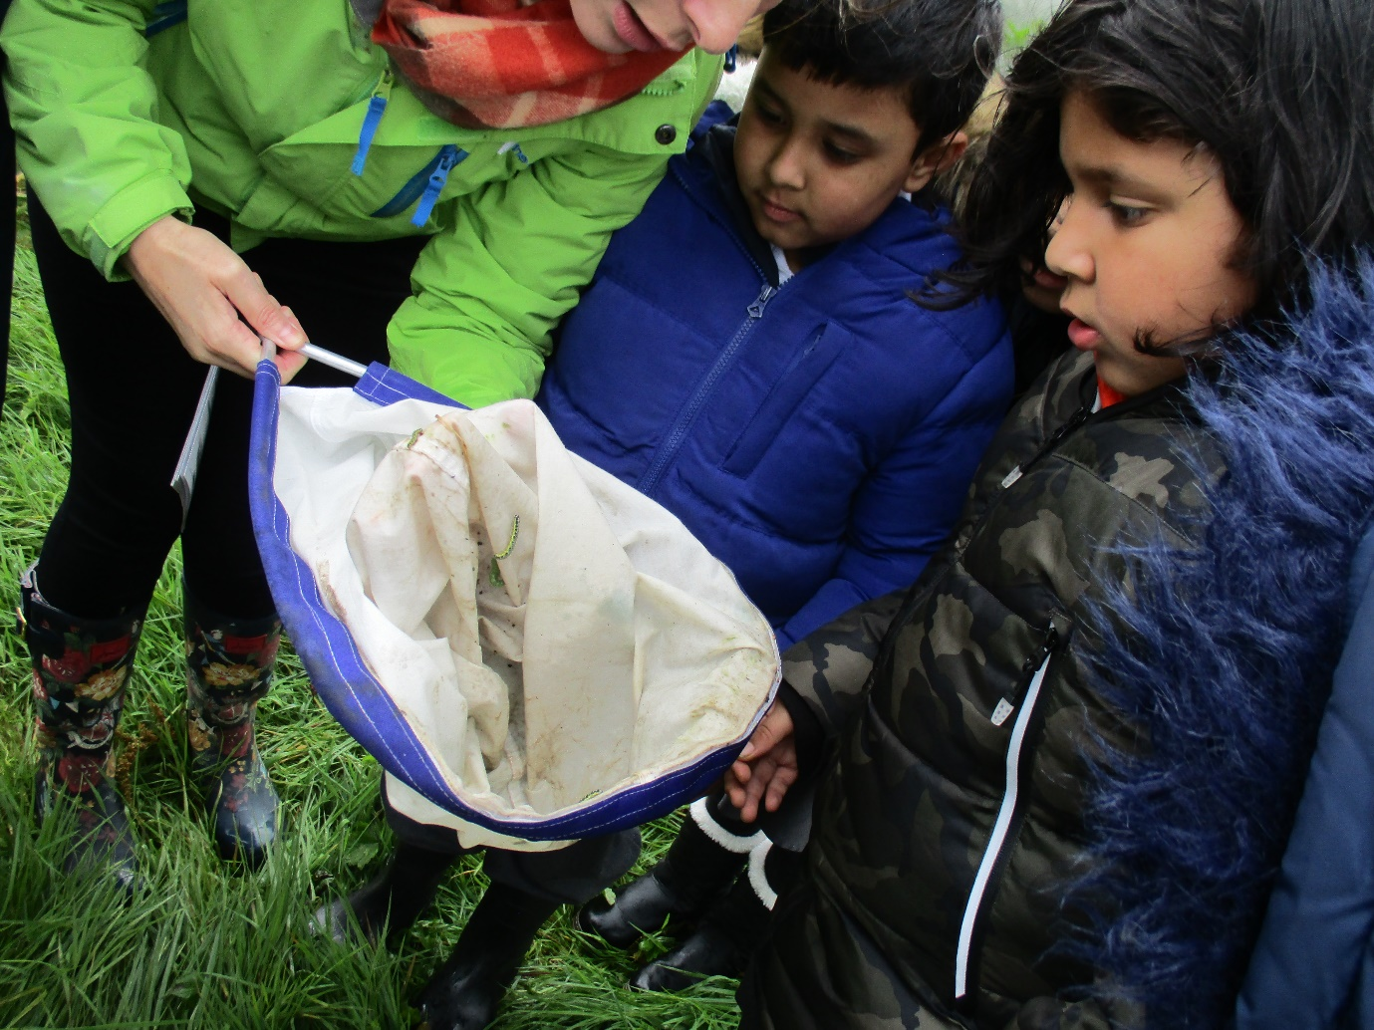
Children discovering caterpillars with the Pendle Hill Landscape Partnership
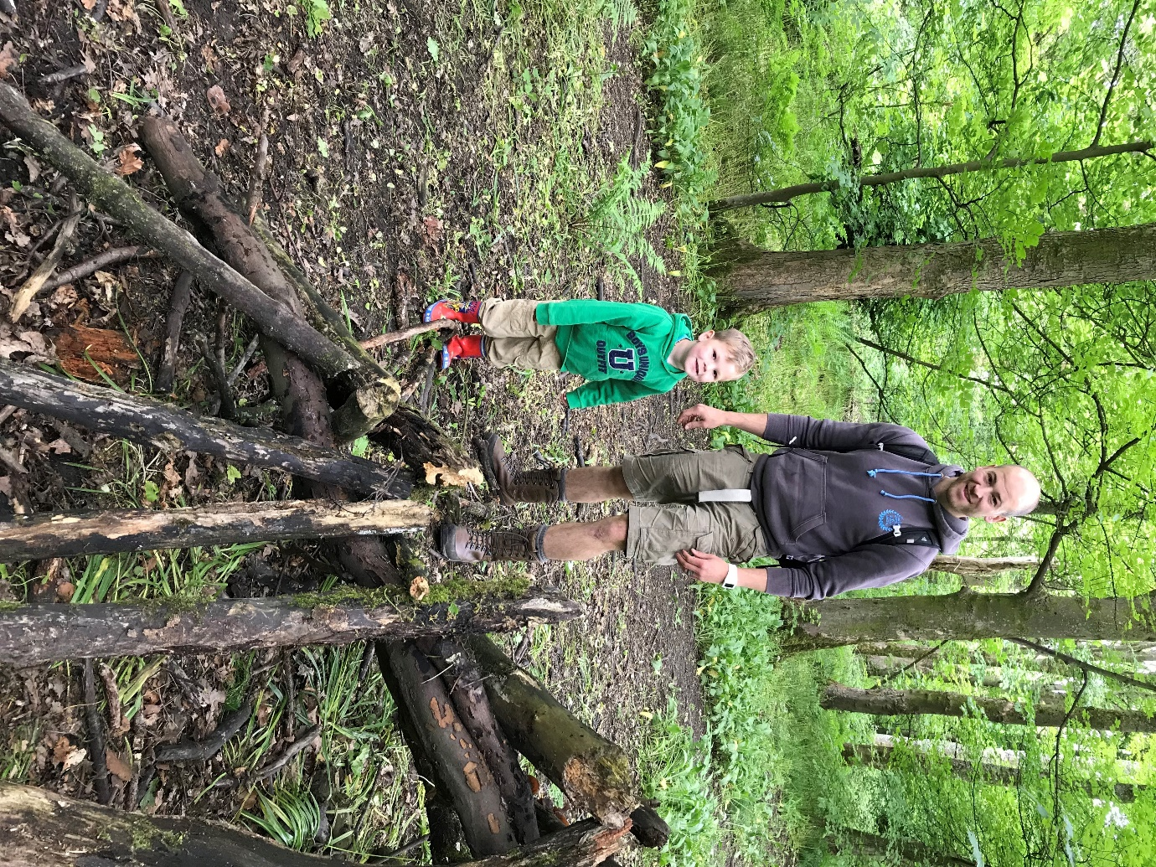
Father and son creating a den, with the Pendle Hill Landscape Partnership

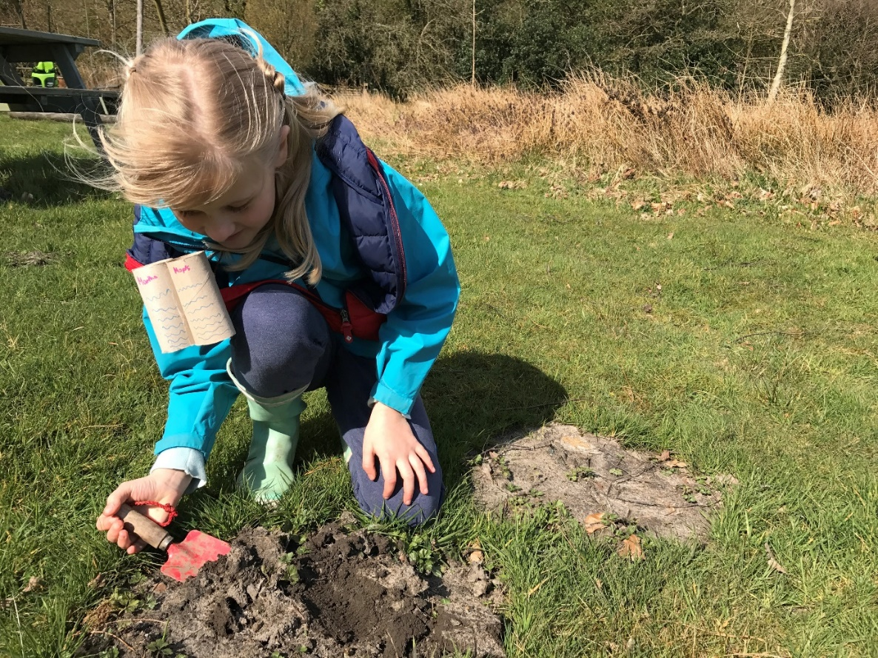
Hunting for minibeasts within the Pendle Hill Landscape
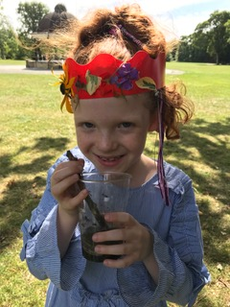
Making wildlife crowns and nature potions with Pendle Hill Landscape Partnership
EDITORS NOTES
- The Pendle Hill landscape partnership is led by the Forest of Bowland AONB.
- The partnership aims to:
I. restore, enhance and conserve the heritage and landscape of Pendle Hill
II. reconnect people with their past and their landscape
III. bring the two sides of the hill together
IV. create a sustainable future for the environment, heritage and for visitors' experience of Pendle Hill
- The scheme was awarded a National Lottery grant of £1.8million by the National Lottery Heritage Fund in January 2018. These funds will be delivered from 2018-2022 and will be matched with a further £1m raised locally.
- The scheme is made up of a dozen projects which safeguard the area's wildlife and heritage and improve people's access to this popular countryside area. We will do this by providing opportunities for training and volunteering; by supporting research and devising creative and digital interpretation to inspire a new generation about our heritage; by restoring important landscape features, and by working with communities to re-tell the stories of radical Pendle people. The scheme will increase pride in this special place and raise aspirations amongst communities, and it will bring in new investment to support the environment and the economy.
- The Pendle Hill landscape partnership is supported by National Lottery players through the Heritage Fund and by the Forest of Bowland AONB. Partners include representatives of parish councils, the landowning and farming community, Pendle and Ribble Valley Borough Councils, Lancashire County Council, statutory bodies, tourism businesses and volunteers.
- Projects will be delivered by the AONB team, plus local delivery partners including In –Situ Arts, the Dry Stone Walling Association, Mid Pennine Arts and Ribble Rivers Trust.
- The Pendle Hill LP covers 120 square kilometres, stretching from Gisburn down to Whalley, and from Clitheroe across to Nelson and Padiham.
- The Hill is well known as a beauty spot and is heavily visited by residents of the local towns: it is a perfect place for walking and cycling. The area's heritage is dominated by the story of the Pendle Witches, but there are lots more stories to tell including the founding of the Quaker movement, non- conformists and radicals, Roman and Bronze Age settlers, medieval farming systems and early industrial developments. The network of dry stone walls and hedgerows give the area a distinctive feel, and the landscape is also important for its wild moorland, rare birds and woodlands.
- For further information contact the LP Scheme Manager cathy.hopley@lancashire.gov.uk on 07891 537835 / 01200 420420
- Visit the project website at www.pendlehillproject.com or visit our Facebook page 'Pendle Hill Project' for up to date news and views.
About the Heritage Fund
Thanks to National Lottery players, we invest money to help people across the UK explore, enjoy and protect the heritage they care about - from the archaeology under our feet to the historic parks and buildings we love, from precious memories and collections to rare wildlife. www.hlf.org.uk Follow us on Twitter, Facebook and Instagram and use #HLFsupported

