PRESS RELEASE
For immediate release 11th March 2021

A Successful Year Of Online Events
2020 was certainly not the year any of us had planned, but that goes without saying. So what happened to an organisation like the Pendle Hill Landscape Partnership when their diary full of pre planned events had to be cancelled for the year? Well…we simply looked at which events could be moved online, and did exactly that. Now, almost a year later, we look back at our online events and think about how successful they have been and how the pandemic made us challenge the way we have previously worked.
Over the past year, in conjunction with the Forest of Bowland AONB, we have held more than 20 online events, all via Zoom, which have enabled us to engage with a whole new audience, with people from as far as Scotland and Devon logging on to join us. All varying in content, our events included National Meadows Day, our ever popular Foodie Foray, Bowland's Bats: Sounds and Detectors, An Introduction to Rewilding & Futurescapes, and the John Muir Celebration Event - Exploring our local hidden natural heritage, to name just a few.
We would like to thank everybody who has been involved in organising our virtual events, and to all those who have attended them. To think we had just over 700 people attending in total, it really does add a new dimension to what we have previously been able to do. With this in mind, and looking ahead to the future, we have decided to continue offering some online events, alongside the "normal" events that we are looking forward to hosting again just as soon as we are able.

We already have some exciting monthly virtual events planned, and you are welcome to join us! Events include a chance to learn about some of the Pendle Hill people who changed the world with our In the Footsteps of Extraordinary People: Introducing the Radicals Trail, event being held on Tuesday 23rd March 6.30pm – 8pm. We also have a talk about Sawley Abbey: The Buildings And People Of A Medieval Monastery which is taking place on Wednesday 21st April 6.30pm – 8pm. Not forgetting Our Bumblebees For Beginners event on Thursday 6th May 12noon – 1pm. To get more information or to find out what other online events we have planned, click here Online Events & Learning | Pendle Hill Landscape Partnership (pendlehillproject.com)
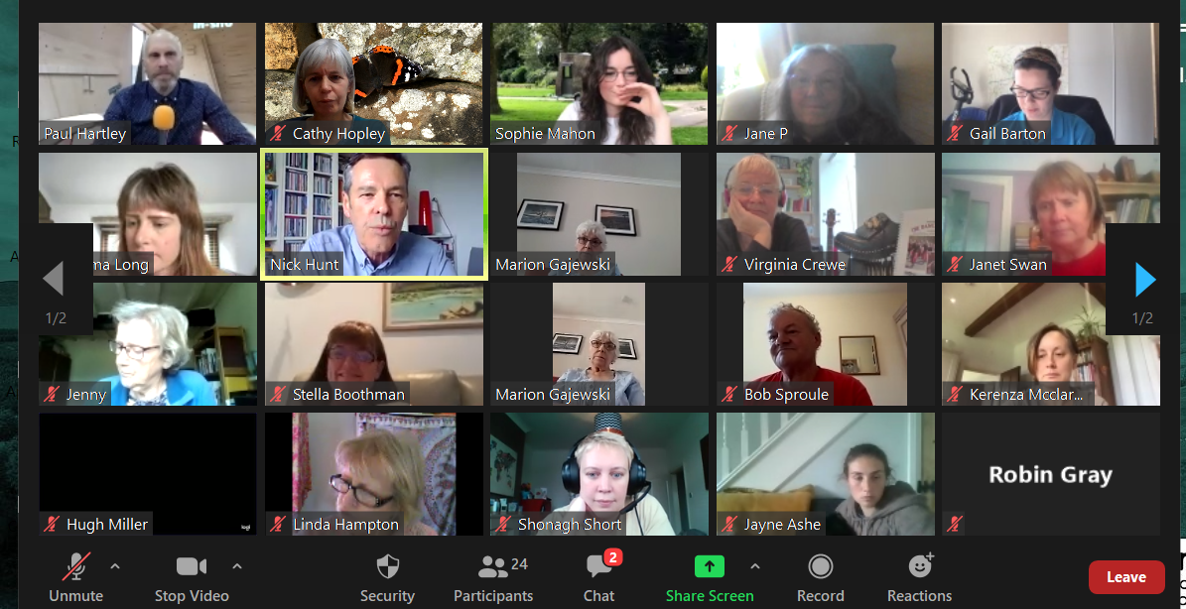
Photo: Digital Gatherings, Episode 1 - Pendle Radicals & Clog Dancing

EDITORS NOTES
- The Pendle Hill landscape partnership is led by the Forest of Bowland AONB.
- The partnership aims to:
I. restore, enhance and conserve the heritage and landscape of Pendle Hill
II. reconnect people with their past and their landscape
III. bring the two sides of the hill together
IV. create a sustainable future for the environment, heritage and for visitors' experience of Pendle Hill
- The scheme was awarded a National Lottery grant of £1.8million by the National Lottery Heritage Fund in January 2018. These funds will be delivered from 2018-2022 and will be matched with a further £1m raised locally.
- The scheme is made up of a dozen projects which safeguard the area's wildlife and heritage and improve people's access to this popular countryside area. We will do this by providing opportunities for training and volunteering; by supporting research and devising creative and digital interpretation to inspire a new generation about our heritage; by restoring important landscape features, and by working with communities to re-tell the stories of radical Pendle people. The scheme will increase pride in this special place and raise aspirations amongst communities, and it will bring in new investment to support the environment and the economy.
- The Pendle Hill landscape partnership is supported by National Lottery players through the Heritage Fund and by the Forest of Bowland AONB. Partners include representatives of parish councils, the landowning and farming community, Pendle and Ribble Valley Borough Councils, Lancashire County Council, statutory bodies, tourism businesses and volunteers.
- Projects will be delivered by the AONB team, plus local delivery partners including In –Situ Arts, the Dry Stone Walling Association, Mid Pennine Arts and Ribble Rivers Trust.
- The Pendle Hill LP covers 120 square kilometres, stretching from Gisburn down to Whalley, and from Clitheroe across to Nelson and Padiham.
- The Hill is well known as a beauty spot and is heavily visited by residents of the local towns: it is a perfect place for walking and cycling. The area's heritage is dominated by the story of the Pendle Witches, but there are lots more stories to tell including the founding of the Quaker movement, non- conformists and radicals, Roman and Bronze Age settlers, medieval farming systems and early industrial developments. The network of dry stone walls and hedgerows give the area a distinctive feel, and the landscape is also important for its wild moorland, rare birds and woodlands.
- For further information contact the LP Scheme Manager cathy.hopley@lancashire.gov.uk on 07891 537835 / 01200 420420
- Visit the project website at www.pendlehillproject.com or visit our Facebook page 'Pendle Hill Project' for up to date news and views.
About the Heritage Fund
Thanks to National Lottery players, we invest money to help people across the UK explore, enjoy and protect the heritage they care about - from the archaeology under our feet to the historic parks and buildings we love, from precious memories and collections to rare wildlife. www.hlf.org.uk Follow us on Twitter, Facebook and Instagram and use #HLFsupported

