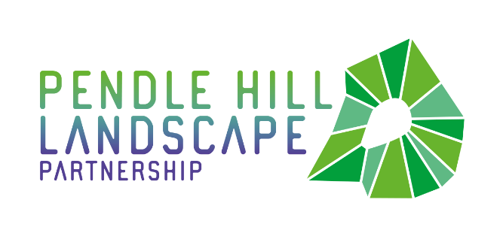
PRESS RELEASE
20th October 2020
Pendle Partnership Work a Success for Everyone!
The Pendle Hill Landscape Partnership's People Enjoying Nature project, has been really successful at offering supported outdoor sessions in the local landscape. However, it could not work without the partnership of the East Lancashire Community Prevention and Engagement Team, part of Lancashire and South Cumbria NHS Foundation Trust (LSCFT). The partnership has added to their successes and has been celebrated as LSCFT's Partnership of the Year at the LSCFT Awards 2020.
The People Enjoying Nature project aims to give local people the opportunity to explore walks and sites across the Pendle Hill countryside, learn new skills and get involved in practical conservation volunteering activities. With the help of Nick Alderson from the CPET team, the PEN project works to engage the benefits that spending time in nature can have on everyone's mental health and well-being.
Supported by the National Lottery Heritage Fund, the PEN project so far has delivered outdoor eco-therapy sessions to 104 different individuals from across Clitheroe, Pendle and Burnley. 2020 plans have been impacted by the Covid 19 pandemic, like most other services and projects. Rather than group sessions, the PEN project has been offering 1 to 1 supported walking and outdoor sessions where possible. The focus on our mental health has never been more important, and the project will continue to encourage accessing nature, local parks and the wider countryside because of the positive benefits on mental health and well-being.
Nick Alderson, Rural Development Officer for CPET says “Since the very beginning of the partnership it has been clear that there has been significant benefits for the community that the PEN project serves. Many participants have accessed the project to gain new skills and experience the benefits of being outdoors, however most importantly have also received social inclusion, which is the project’s main goal. As always it has been a real pleasure to work with the PHLP and notably Jayne Ashe, whose passion and commitment is one of the main driving forces behind the project and partnerships success.”
Lucie Barton, Team Leader at CPET, says “The PEN project and the partnership between ourselves and the PHLP has been a fantastic success. We look forward to the future of the partnership and the positive outcomes that the project can and will achieve for individuals who participate. ”
The PHLP hopes that the People Enjoying Nature project will show how important supported eco-therapy sessions are for everyone in society, and how post Covid 19 this support is going to be needed more than ever.

EDITORS NOTES
The Pendle Hill landscape partnership is led by the Forest of Bowland AONB.
- The partnership aims to:
I. restore, enhance and conserve the heritage and landscape of Pendle Hill
II. reconnect people with their past and their landscape
III. bring the two sides of the hill together
IV. create a sustainable future for the environment, heritage and for visitors' experience of Pendle Hill
- The scheme was awarded a National Lottery grant of £1.8million by the National Lottery Heritage Fund in January 2018. These funds will be delivered from 2018-2022 and will be matched with a further £1m raised locally.
- The scheme is made up of a dozen projects which safeguard the area's wildlife and heritage and improve people's access to this popular countryside area. We will do this by providing opportunities for training and volunteering; by supporting research and devising creative and digital interpretation to inspire a new generation about our heritage; by restoring important landscape features, and by working with communities to re-tell the stories of radical Pendle people. The scheme will increase pride in this special place and raise aspirations amongst communities, and it will bring in new investment to support the environment and the economy.
- The Pendle Hill landscape partnership is supported by National Lottery players through the Heritage Fund and by the Forest of Bowland AONB. Partners include representatives of parish councils, the landowning and farming community, Pendle and Ribble Valley Borough Councils, Lancashire County Council, statutory bodies, tourism businesses and volunteers.
- Projects will be delivered by the AONB team, plus local delivery partners including In –Situ Arts, the Dry Stone Walling Association, Mid Pennine Arts and Ribble Rivers Trust.
- The Pendle Hill LP covers 120 square kilometres, stretching from Gisburn down to Whalley, and from Clitheroe across to Nelson and Padiham.
- The Hill is well known as a beauty spot and is heavily visited by residents of the local towns: it is a perfect place for walking and cycling. The area's heritage is dominated by the story of the Pendle Witches, but there are lots more stories to tell including the founding of the Quaker movement, non- conformists and radicals, Roman and Bronze Age settlers, medieval farming systems and early industrial developments. The network of dry stone walls and hedgerows give the area a distinctive feel, and the landscape is also important for its wild moorland, rare birds and woodlands.
- For further information contact the LP Scheme Manager cathy.hopley@lancashire.gov.uk on 07891 537835 / 01200 420420
- Visit the project website at www.pendlehillproject.com or visit our Facebook page 'Pendle Hill Project' for up to date news and views.
About the Heritage Fund
Thanks to National Lottery players, we invest money to help people across the UK explore, enjoy and protect the heritage they care about - from the archaeology under our feet to the historic parks and buildings we love, from precious memories and collections to rare wildlife. www.hlf.org.uk Follow us on Twitter, Facebook and Instagram and use #HLFsupported

