PRESS RELEASE
For immediate release 3rd April 2020
Tree-mendous effort by local school pupils
Three East Lancashire schools have helped play their part in tackling climate change by planting over 50 trees in the Forest of Bowland AONB.
Pupils from Roughlee Church of England Primary, Newchurch St Mary’s Primary and Clitheroe's Brookside Primary school, planted native tree saplings along Twiston Beck near Downham, in the Ribble Valley. They were helped by Ribble Rivers Trust and Pendle Hill Landscape Partnership, which is funded by the National Lottery Heritage Fund.
Ribble Rivers Trust provided each primary school with a tree planting demonstration before the pupils got to work on planting a variety of species. Saplings included; alder, oak and rowan, which once established will help prevent flooding in the future and create a new woodland for wildlife.
“Planting trees next to water courses acts as a barrier to water. The roots of trees anchor the soil in place, meaning there is more of it to absorb water, and the less soil that is in the river means there is greater capacity for water in the channel,” explained Ribble Rivers Trust's Woodland Creation Officer Kristina Graves.
“Whilst more woodland won’t stop flooding happening ever again, it will contribute to less devastating consequences for people and homes after bouts of heavy rainfall.”
Since the tree planting at the start of the year, a pupil at Roughlee Church of England Primary has gone a step further by planting a dedicated tree within the school’s grounds.
Headteacher Mr Elliott said: “We received a rowan tree at the Pendle Borough Schools Climate Movement in 2019. Having just learnt the best method to plant a tree, we thought we should plant ours. One of our Year 6's carried out the task within the school grounds. I hope this tree will remind us about our great day out at Twiston and the positive action we can take to help the local environment.”
Ellie Brown, part of the Ribble Rivers Trust team, explained to the pupils the vital roles trees play in tackling climate change: “Trees can help to mitigate climate change through a process called ‘carbon sequestration’. We explained this process to the children through playing games, so they understood how trees take carbon out of the atmosphere and store it within different plant parts. By the end of the trip, the children felt they had helped to fight climate change.”
Alison Cross, the Pendle Hill Landscape Partnership projects' Outdoor Learning Officer, who is funded by the Ernest Cook Trust, taught each class about the composition of plants: “It was great to see the children apply their knowledge about plants from their classroom lessons. The pupils and teachers left with a broader knowledge of tree species and how to identify them.”
Newchurch St Mary’s Primary Headteacher, Mrs Nightingale said: "The day in February was a brilliant hands on experience for our Key Stage 2 children. All activities were appropriate and fun, and pupils and staff learnt loads. Our thanks go to Ribble Rivers Trust and Pendle Hill Landscape Partnership project.”
Pendle Hill Landscape Partnership works with many schools within the Ribble Valley and Pendle borough area, to help teachers with outdoor learning. Alison aims to work with these schools in the future, to help them make the most of the Pendle Hill landscape for school trips and tree planting opportunities in winter 2020/2021. To learn more, head to: https://pendlehillproject.com/project/volunteering-learning
If you would like to find out more about Pendle Hill Landscape Partnership tree planting project and working with schools, then get in touch with the team at pendlehill.lp@lancashire.gov.uk or call 01200 420420.

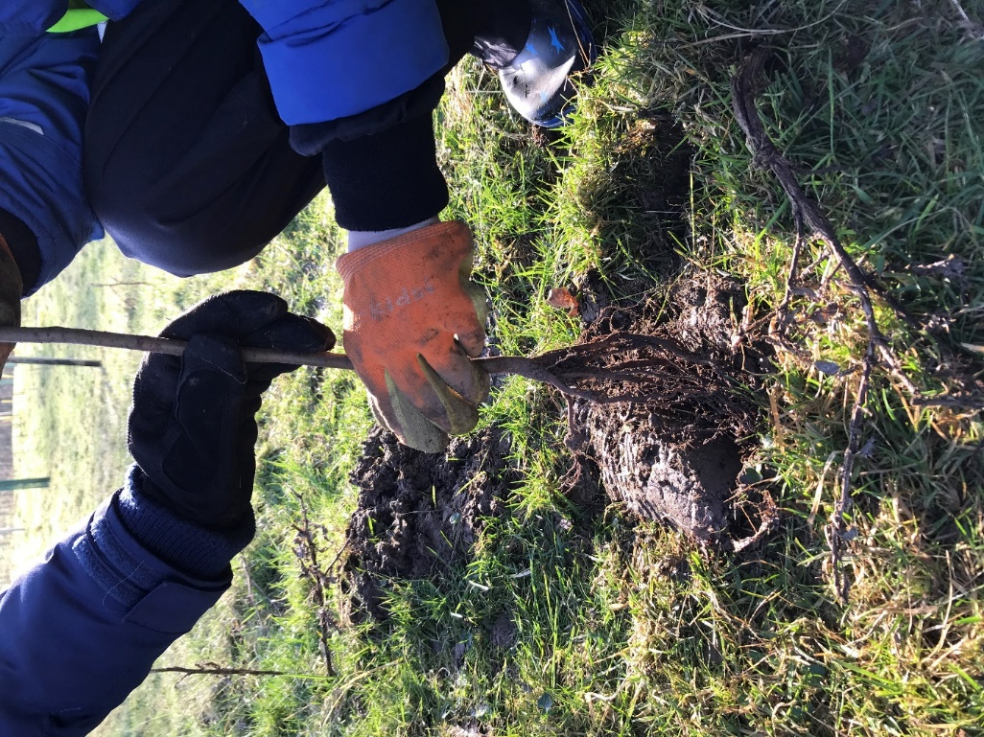
Treemendous roots
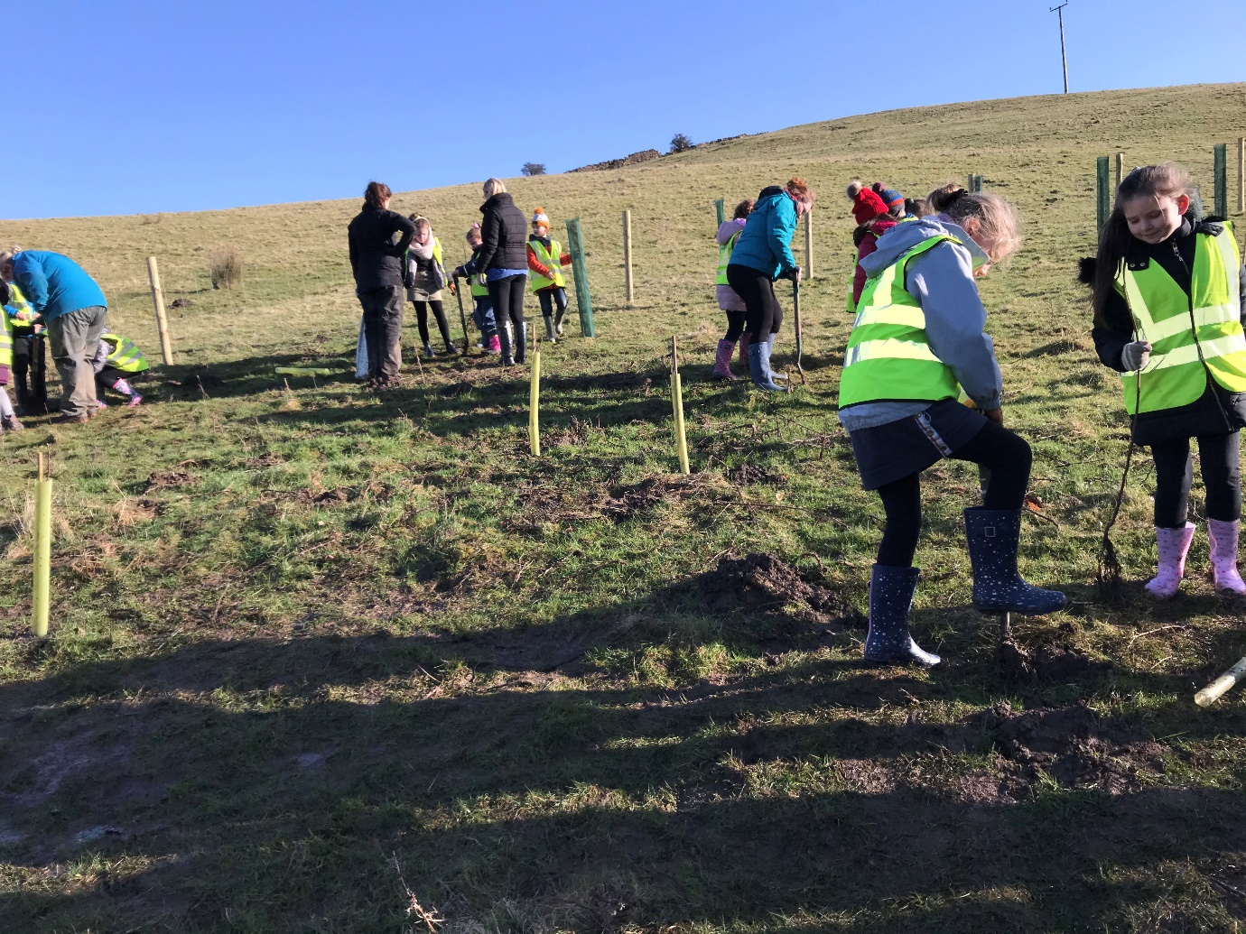
Pupils from Clitheroe Brookside school, tree planting in Twiston

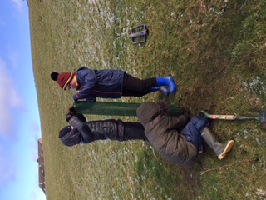

Pupils from Newchurch school, tree planting in February

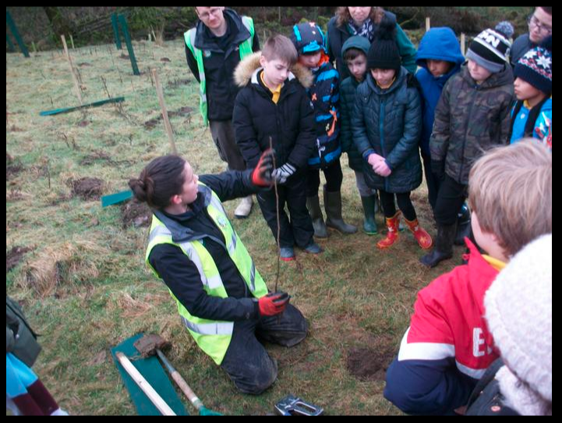
Ellie, from Ribble Rivers Trust, giving Roughlee school pupils a tree planting demonstration in January

EDITORS NOTES
- The Pendle Hill landscape partnership is led by the Forest of Bowland AONB.
- The partnership aims to:
I. restore, enhance and conserve the heritage and landscape of Pendle Hill
II. reconnect people with their past and their landscape
III. bring the two sides of the hill together
IV. create a sustainable future for the environment, heritage and for visitors' experience of Pendle Hill
- The scheme was awarded a National Lottery grant of £1.8million by the National Lottery Heritage Fund in January 2018. These funds will be delivered from 2018-2022 and will be matched with a further £1m raised locally.
- The scheme is made up of a dozen projects which safeguard the area's wildlife and heritage and improve people's access to this popular countryside area. We will do this by providing opportunities for training and volunteering; by supporting research and devising creative and digital interpretation to inspire a new generation about our heritage; by restoring important landscape features, and by working with communities to re-tell the stories of radical Pendle people. The scheme will increase pride in this special place and raise aspirations amongst communities, and it will bring in new investment to support the environment and the economy.
- The Pendle Hill landscape partnership is supported by National Lottery players through the Heritage Fund and by the Forest of Bowland AONB. Partners include representatives of parish councils, the landowning and farming community, Pendle and Ribble Valley Borough Councils, Lancashire County Council, statutory bodies, tourism businesses and volunteers.
- Projects will be delivered by the AONB team, plus local delivery partners including In –Situ Arts, the Dry Stone Walling Association, Mid Pennine Arts and Ribble Rivers Trust.

- Ribble Rivers Trust (RRT) is a local environmental charity established in 1997 to protect and restore the rivers, streams and watercourses within the Ribble catchment and to raise public awareness of the value of our local rivers and streams. The Ribble catchment is the area of land that is drained by the River Ribble and its major tributaries; the Hodder, Calder and Darwen. It covers a varied landscape, from the rural hills of the Yorkshire Dales and the source of the River Ribble, to major urban areas of Lancashire including Blackburn, Burnley and Preston. For more information please contact 01200 444452 or visit www.ribbletrust.org.uk

- The Pendle Hill LP covers 120 square kilometres, stretching from Gisburn down to Whalley, and from Clitheroe across to Nelson and Padiham.
- The Hill is well known as a beauty spot and is heavily visited by residents of the local towns: it is a perfect place for walking and cycling. The area's heritage is dominated by the story of the Pendle Witches, but there are lots more stories to tell including the founding of the Quaker movement, non- conformists and radicals, Roman and Bronze Age settlers, medieval farming systems and early industrial developments. The network of dry stone walls and hedgerows give the area a distinctive feel, and the landscape is also important for its wild moorland, rare birds and woodlands.
- For further information contact the LP Scheme Manager cathy.hopley@lancashire.gov.uk on 07891 537835 / 01200 420420
- Visit the project website at www.pendlehillproject.com or visit our Facebook page 'Pendle Hill Project' for up to date news and views.
About the Heritage Fund
Thanks to National Lottery players, we invest money to help people across the UK explore, enjoy and protect the heritage they care about - from the archaeology under our feet to the historic parks and buildings we love, from precious memories and collections to rare wildlife. www.hlf.org.uk Follow us on Twitter, Facebook and Instagram and use #HLFsupported

